## Store name: The Bowl

## Concept idea: Web store that sells exclusively ramen noodles of all variety.

## Color Scheme:

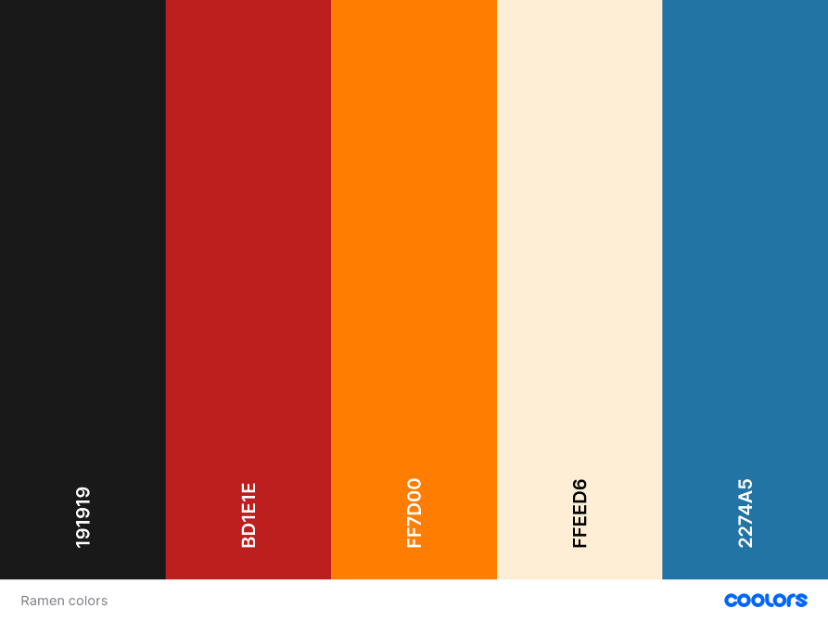

Logo:



## Fonts:

1) Solway:

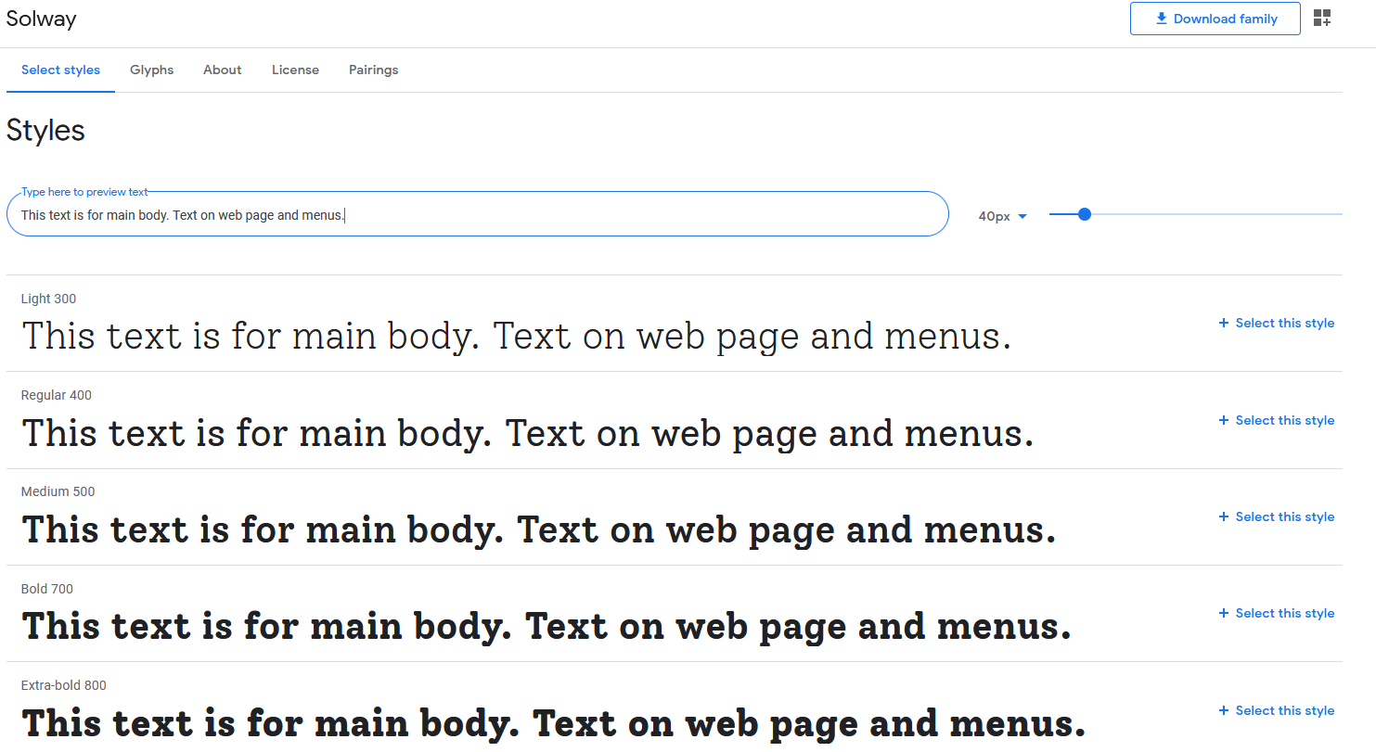

2) Nova flat

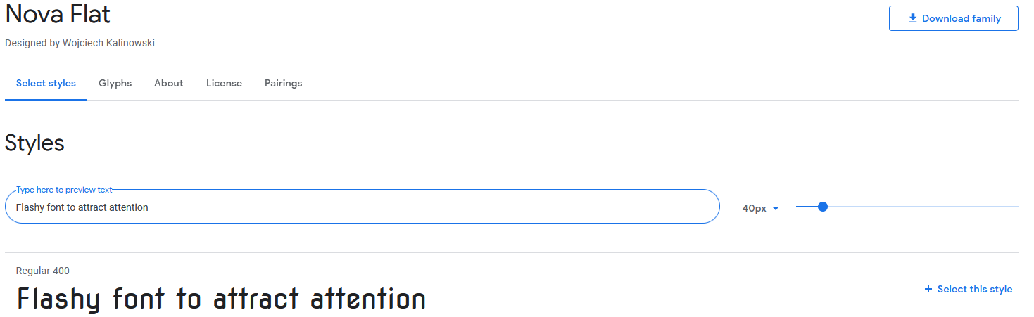

3) Amatic SC

